StePhanos Kung Fu Club

QIUXUAN ZHANG - 104372153

JIA ZHU - 104531723

MIN GUO – 104443534

Apr 09, 2017

# dependency diagram in 3nf



Relational schema: 3NF (Stu_Num, Stu_FName, Stu_DOB, Stu_Join_Date, Stu_Pho­­_Num, Stu_Email, Stu_Add, Prt_Name, Stu_Rel, Prt_Pho_Name, Prt_Email)

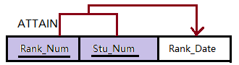

Relational schema: 3NF (Rank_Num, Stu_Num, Rank_Date)

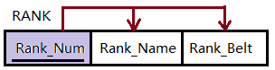

Relational schema: 3NF (Rank_Num, Rank_Name, Rank_Belt)

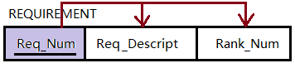

Relational schema: 3NF (Req_Num, Req_Dscript, Rank_Num)

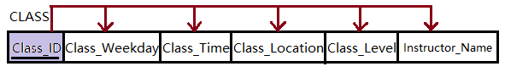

Relational schema: 3NF (Class_ID, Class_Weekday, Class_Time, Class_Location, Class_Level, Instructor_Name)

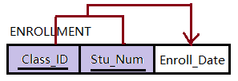

Relational schema: 3NF (Class_ID, Stu_Num, Enroll_Date)

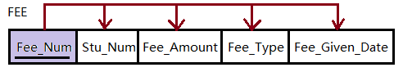

Relational schema: 3NF (Stu_Num, Fee_Amount, Fee_Type, Fee_Given_Date)

# ERD

# Database Design

There are 7 table in our design.

Student:

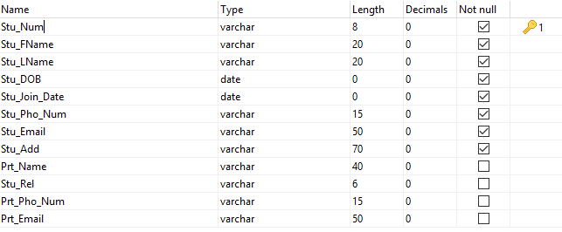

Class:

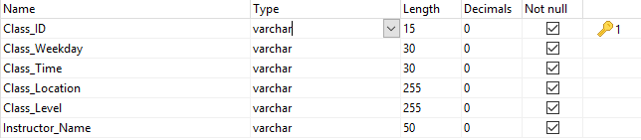

Enrollment:

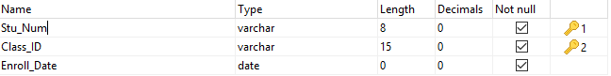

Fee:

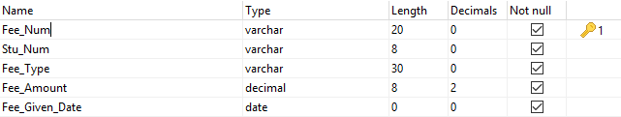

Rank:

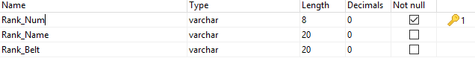

Attain:

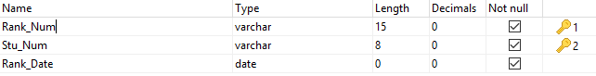

Requirement:

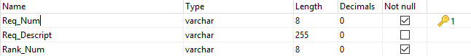

# System Demo

No username/password in this system.

# Source codes

## Manager Student function:

## 

## Fee Inquiry function:



## Class Inquiry function:



## Rank Inquiry function:



## Rank Information function:



## Database connection:



## Other Codes:



A complete system using any programming language for the interface and any DBMS of your choice. This includes all system files including source code.